Table of Contents
I. Pre-Drafting 2
II. Drafting 5
A. General Guidance 5
B. Section I. COMMODITY DESCRIPTION 5
C. Section II. SPECIFICATIONS 8
D. Section III LABELING REQUIREMENTS 10
E. Section IV. PACKAGING AND SHIPPING REQUIREMENTS 10
F. Section V. SHELF LIFE AND MATERIAL EXPIRATION 11
G. Section VI. DOCUMENTATION REQUIREMENTS 11
H. Section VII. NON-TECHNICAL PLANT-SPECIFIC REQUIREMENTS 11
I. Section VIII. CHANGE NOTIFICATION 11
III. API Assessment (API = China RX) 11
IV. Internal Review 11
V. External Review 12
VI. Initiating the Specification Change Request (CR) 16
VII. Internal Approval of ICS (CR) 16
VIII. External approval of ICS 18
IX. CR Closure/Final Approval of ICS 18
X. Final Communication 19

- Pre-Drafting
  - Determine Scope
    - ASL
      - Filter the ASL for the applicable commodity.
      - All AN plants/TPMs except those that are inactive are required to be in scope of the ICS update (this includes internal review and CR approval).
Note: If a supplier is in restrictive status across all sites, check the ASL comments for further direction or reach out to the appropriate procurement contact.
      - If at any point during your specification update you are informed that a plant does not receive the material, work with procurement and appropriate GSQA contacts (US by category/OUS by region) to request that this line be removed from the ASL
    - Incoming Acceptance Document Tracker (ICS, RMTM and CP)
      - Add the commodity number to the Incoming Acceptance Document Tracker with a status of “Drafting.”
        - If the commodity is already on the specification tracker and not fully approved:
          - The commodity number will turn red when entered
          - Coordinate with current owner to ensure all necessary updates are included or add your name if no owner is listed
        - If the commodity is NOT on the specification tracker:
          - Fill in all possible columns (be sure to add the start date as the day update work begins)
      - The “API Assessment Required” column provides guidance on how to manage an API spec.
        - Not Required = No additional action needed
        - Assessment Required = Required actions captured in Section 3. API Assessment
      - The “China Standard Requirements” column provides one options below (See II. B. 2. g. for detailed guidance)
        - Enterprise Standard
        - China Standard
        - Check ASL

    - DevEx
      - Search for the commodity under “Projects” (Project Search) for any projects in the “In Process” status.
      - For all projects in process, reach out to the GSQA contact to provide awareness of the specification update. Determine if any new plants/TPMs or suppliers will need to be included in the review and approval process.

  - Pull Reference Documents from M-Files
Note: “Spec Metrics” can be used to assess what files are available in M-Files - PBI Specification Update Tracker - Power BI
      - Current Specification (RMS Only, ISM Only, RMS and ISM, or ICS Only)
        - Remove the initial “0” from the commodity number when searching for OUS specific documents (e.g. RMS or RMP)
        - If the current specification is on the ICS template, determine if it is on the current version of the AN ICS Template:
          - In DMSPROD, Highlight the current specification version in PDF format, go to “Metadata,” scroll down to Doc Type Variant Attributes,” and review “Template Version”
        - If the current specification is NOT on the ICS template or NOT on the current version of the ICS template, search M-files for “AN ICS Template,” download and save as “ICS[5-Digit Commodity #] Proposed Draft”
        - If the current specification IS on the current version of the template:
          - Pull the Word version (also known as the “Native File”) of the current specification.
            - Open the Desktop file (DMSPROD)
            - Enter “ICS[COMMODITY NUMBER]” in the search field and select “Document” as a filter
            - Select the most recent PDF version of the ICS in in Effective or Approved “State”
            - Click “carrot” next to the PDF to expand
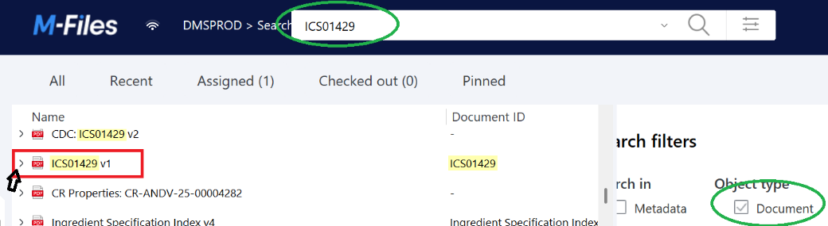

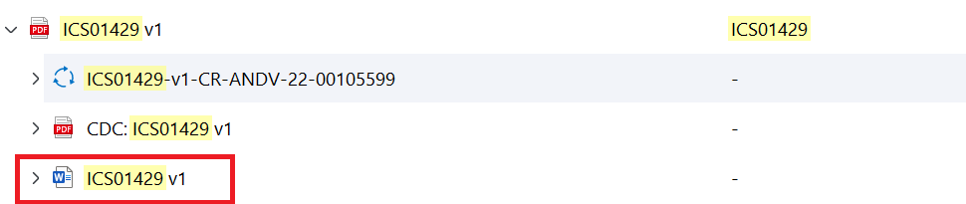
            - Double click on the Word version to open and save as “ICS[5-Digit Commodity #] Proposed Draft” (See II.A.1. for further guidance)
            - The current word version will be in Released “State” and match the current version of the most recent PDF version
      - Where Used Report Ingredient Where Used Search.
      - Supplier COA(s) (Optional)

        - Supply to US Plants
          - Reference supplier COAs in M-files or the RIQA homepage (Home.aspx)
        - Supply to OUS Plants/TPMs
          - Consult applicable site Incoming QA or Site QA for supplier COAs.
      - Region Specific Documents (Optional – for site specific reference only)
        - US
          - Critical Parameters (CP)
          - Raw Material Testing Manual (RMTM)
        - Select OUS and TPM
          - Raw Material Acceptance Plan (RMPs Decoder with plant names)
        - Zwolle
          - ARMS (reference for requirements not currently on the ICS)

- Drafting
Prior to Drafting
Flavors - Reference the Flavor Job Aids for flavor-specific guidance
Premixes – Contact Chris Coury for premix specific template changes

General Guidance
    - If the existing specification is on the current version of the ICS template, pull the Word version from M-files, save as “ICSXXXXX Proposed Draft [Date], create a redline of all proposed updates using “Track Changes”
    - If the existing specification is NOT on the current version of the ICS template:
      - Pull the AN ICS Template, save as “ICSXXXXX Proposed Draft [Date],create a clean version of the document
      - Transfer relevant requirements from the existing specification while using current template verbiage where applicable
      - All changes from the current ISM, RMS, or ICS must be documented in the DRJ if it is not linked to the template update only
    - The default for the initial draft is to list requirements as applicable for all sites to prevent future SRAs from driving specification updates. (i.e. Add “All” to the Applicable Plants column for specifications and do not call out specific sites for requirements when possible)
    - TPM-Specific Requirements – applicable to Specification Table and Shelf Life Table
      - Do NOT include TPM names
      - If all TPMs align – add “TPMs”
      - If all TPMs do not align, differentiate as needed:
        - TPM US vs TPM Non-US
        - If non-US TPMs don’t align or US TPMs don’t align, refer to the ASL to include the necessary location details for differentiation, beginning with most general to most specific as necessary (e.g. region (TPM EU), country (TPM France), state (TPM Ohio), city (TPM Kilkenny))
    - Documentation of updates
      - It is recommended to document the description along with a reason and justification of each change while creating the proposed draft.
      - Each update to the specification or changes to the template must be documented with a Description, Reason, and Justification (DRJ) within the M-Files Change Request (CR) and when applicable, included in the API review
      - Reference Commonly Used DRJs (ICS,RMTM,CP) as needed
      - List the Reason/Justification for each Description of change separately for easier copy and paste transfer to the CR and API form (if applicable)

Section I. COMMODITY DESCRIPTION
    - Cross Functional Contacts to consult as needed:
Requirement | Functional Group to Contact
Basic Description | PR&D
GMO Status Requirement | Regulatory, PR&D
Monograph | Regulatory
 | PR&D
China GB | China Regulatory (China Market Only)
 | Regulatory
E Number | Regulatory
EU Contaminants | Regulatory
 | GAFS

    - General Guidance
      - Follow template guidance, for any statement that indicates “remove if not applicable” and remove unless present on previous version of the specification.
      - If the previous version of the specification has a statement that does not align, update to the most recent template verbiage OR consult the above functional group for guidance.
        - Example: Older versions of the EU contaminants statement must be replaced with the current ICS template verbiage
      - Do NOT include supplier trade name or product codes on the ICS unless the ingredient is a flavor
      - If an ICS is being created from an ISM and RMS and a discrepancy exists between the two, place the most restrictive requirement on the ICS. If direction is unclear consult the above functional groups for guidance.
      - Non-GMO Statement
        - Include the non-GMO statement if included on the current specification.
        - If requested to add by an AN representative and the statement is not on the current specification, consult the appropriate contacts prior to adding (II.B.1.)
        - If the ingredient MUST meet a non-GMO requirement, the non-GMO statement must be on the specification.
        - Devex Key Characteristics provides what the material is able to meet (consult the appropriate contacts (II.B.1.) to determine if the material MUST be Non-GMO)
NOTE: Historically there is no consistent execution as to whether the statement on the specification is stating a “Must Have” requirement or what the material is naturally and/or suppliers can meet.
      - Monograph/Compendial Grade
        - Include the monograph statement if included on the current specification or requested by an AN representative.

        - If R&D requests addition of the monograph statement:
          - Request R&D review and confirm the proposed draft specifications are in alignment with the monograph. (See Job Aid - Accessing Databases and Important Links.docx for instructions on obtaining access to the monographs)
          - GSQA is not required to cross reference the current spec with the monograph
        - If Regulatory or R&D indicate that an ingredient is used in finished products sold in the EU, the appropriate monograph statement must be included on the specification.
      - China Requirements - See QR #1058207 for further details including GB compliance statement guidance
        - The “China Standard Requirements” column on the Incoming Acceptance Document Tracker will populate one of the following for guidance:
          - Enterprise Standard
            - Consult China Regulatory for specification requirements (products sold in China).
            - Jiaxing Plant will advise on exported products during internal review.
              - Include reference to the following footnote for any added Enterprise Standard requirements: “China Regulation Required”
- The statement of GB compliance is not required in the Description section of the ICS.

          - China Standards
            - Review Devex Material Master "Key Characteristics" for applicable GB#
            - Reach out to China Regulatory if no GB# is listed or requirement is unclear
            - Reference QR #1058207 for further guidance
            - Request a GB compliance statement from the supplier per QR #1058207
            - Include the GB compliance statement in the Commodity Description section of the ICS, “The material shall comply to applicable GB standards/Regulations/Notices/MOH Announcements/NHC Announcements as stated in the supplier compliance statement”
          - Check ASL
            - If not supplied to Jiaxing, no further action is required
            - If supplied to Jiaxing
              - Include the GB compliance statement in the Commodity Description section of the ICS, “The material shall comply to applicable GB standards/Regulations/Notices/MOH Announcements/NHC Announcements as stated in the supplier compliance statement”
              - Review Devex Key Characteristics for applicable GB#
              - Reach out to Division Regulatory if no GB# is listed
              - Request a GB compliance statement from the supplier per QR #1058207

  - Section II. SPECIFICATIONS
    - Cross functional Contacts to consult as needed
Requirement | Functional Group to Contact
Appearance/Flavor/Taste/Aroma | R&D (Sensory) & Incoming QA (OUS)
Specification ranges/limits  (excluding micro) | R&D (PR&D, GAFS, Sensory depending on type of change )
China Standards | Reference Incoming Acceptance Document tracker “China Standard Requirements” column, DexEx Key characteristics, and see QR #1058207 for further guidance
Enterprise Standards | China Regulatory
Contaminant Limits | GAFS
 | Regulatory (Monograph related)
Micro Specs/UOM/Testing | Global Micro

    - General Guidance
      - Analytical Specifications
        - Transfer all analytical parameters from the current specification(s) and corresponding COA requirements
        - Combine duplicate parameters to the most restrictive across all AN Sites for specification limits and COA requirements (See section IV. A.b.2. for Internal Review guidance)
      - Microbiological Specifications
        - Request completion of the table below for all active plants/TPMs to determine all applicable use cases (use cases as defined by AN06-99-004)
          - Use Case Contacts
            - US Plants: PR&D
            - OUS Plants: Site R&D
            - TPMs: TPM R&D
          - Add a column for each plant/TPM
          - Include the Where Used Report in the request
Commodity (XXXXX) | AN Plant Name | AN Plant Name | TPM Name | FPs sold to India (Y/N)  If Y note AN Plant
Major/Dry Blended/Infant |  |  |  | N/A
Minor/Dry Blended/Infant |  |  |  | N/A
Major/Dry Blended/Non-Infant
Minor/Dry Blended/ Non-Infant |  |  |  | N/A
Major Non-Dry Blended Powder
Minor Non-Dry Blended Powder |  |  |  | N/A
Major in Liquid |  |  |  | N/A
Minor in Liquid |  |  |  | N/A
Note: minor = less than 2% of finished product

        - Once all sites have provided use cases, add the most restrictive and all-inclusive micro requirements from AN06-99-004 Section 5.2. to the proposed draft.
          - More restrictive micro limits on the current specification must also be updated to the GMS including removal of additional micro limits.
          - The following is the only footnote which should be added to the ICS when applicable: “cfu/g is equivalent to MPN/g where MPN = Most Probable Number as a statistical estimate of the population.” (If the previous version of the specification includes additional micro footnotes from AN06-99-004, these should be removed.)
          - Follow the GMS nomenclature, specifications and units of measure (including italicizing specific parameter names).
          - Note: CP and RMP micro requirements may differ from the ICS. These documents outline requirements for region specific use and not global use. It is expected that a justification is provided within the DRJ for the respective regional document
      - China Standard Requirements
        - See section II.B.2.g for initial guidance
        - If material must meet China Enterprise standards:
          - Consult China Regulatory for specific requirements
          - Add testing requirements to the specification
            - Include the applicable plant if unique requirement that cannot be met by all supplier/region combinations
            - If there is already a requirement and it is more restrictive than the Enterprise Standard, leave the more restrictive requirement. Note in the DRJ the discrepancy and the specific value to document for future reference.
            - Add “China Regulation Required” as a foot note for each Enterprise Standard parameter
          - Jiaxing site QA will advise if additional Enterprise Standards are required for products sold outside China
        - If material must meet China standards:
          - Confirm the China standards statement is added to Section I, “The material shall comply to applicable GB standards / Regulations / Notices /MOH Announcements/NHC Announcements as stated in the supplier compliance statement”
          - Review QR #1058207 for required updates to the verbiage above the specification table
          - Remove individual GB testing requirements listed on the current specification (if no overlap with other AN sites)
          - Remove the GB Monitoring table.

    - COA requirements
      - For Analytical testing, the COA (Y or N) requirements will remain as it is on the current specification(s)
      - If you are referencing an ISM and/or RMS this is indicated in the “COA Requirements section” of these documents
      - For all Micro specifications, add “Y” for the COA requirement
        - Note: Enterprise Standard Micro Specifications should be added with “N” unless overlapping with GMS
    - Formatting Best Practices
      - List all analytical testing requirements first followed by all micro testing requirements
      - Replace Not Less Than (NLT) or Not More Than (NMT) with ≥ or ≤ respectively
    - Micro Specifications
      - Add “maximum” to the micro limits when no limit type is included in the AN06-99-004 table (e.g. 10 cfu/g should be 10 cfu/g maximum)

Section III LABELING REQUIREMENTS
    - General Guidance
      - Follow the AN ICS Template verbiage

Section IV. PACKAGING AND SHIPPING REQUIREMENTS
    - General Guidance
      - Follow the AN ICS Template verbiage
      - Remove any storage conditions (documented at the site level due to variations)
      - Remove additional generalized verbiage such as a list of acceptable packaging options
      - If specific packaging is stated as a requirement, consult all plants to confirm verbiage should remain on the specification.
      - The pre-ship statement is added for all premixes used in infant products for US distribution and is applicable for US and Cootehill
        - The following require the pre-ship verbiage (pre-shipped for Cootehill)
01370
17159
33053
33857
42285
63529
        - US Plants – For all other premixes outside the above, confirm the pre-ship status by reviewing the CP.
          - Test Site = C or L: Remove the pre-ship verbiage
          - Test Site = A : Keep the pre-ship verbiage

Section V. SHELF LIFE AND MATERIAL EXPIRATION
    - General Guidance
      - The table documents the AN shelf life for supplier visibility
      - This section should only be filled if the AN shelf life is significantly shorter than the supplier shelf life and procurement/inventory teams are aware of issues resulting from this discrepancy
      - The minimum remaining shelf life is based on AN’s remaining shelf life and not the supplier’s
      - See Drafting a.ii for TPM naming guidelines

Section VI. DOCUMENTATION REQUIREMENTS
    - General Guidance
      - Follow AN ICS Template verbiage

Section VII. NON-TECHNICAL PLANT-SPECIFIC REQUIREMENTS
    - Remove the India specific verbiage from the ICS template or the current specification if included (this statement is no longer required per Division RA)
    - If no requirements are on the current specification, add Not Applicable
    - If the current specification includes requirements, consult the impacted site to confirm whether those requirements remain applicable

Section VIII. CHANGE NOTIFICATION
    - General Guidance
      - Follow AN ICS Template verbiage

API Assessment (API = China RX)
  - Reference the Incoming Acceptance Document Tracker to determine if an API assessment is required (See section I.A.2.b. for further guidance). If an API assessment is needed, reference the Zwolle API Review Process Job Aid.docx for assessment details. If no API assessment is required, move on to Internal Review. Ask Sedona for new link?

- Internal Review
  - General Guidance
    - Internal Communication
      - Send an email using the internal review template (Internal Review)
        - The Ingredient Spec Review Form (ISRF), AN11-99-002-F-001, can be used as a guideline to determine the appropriate recipients (See ISRF Job Aid Folder)
        - Include the Description and the associated Reason/ Justification for each change
        - Due date guidelines
          - Allow 2 weeks for all AN plant contacts and 3 weeks for AN TPM contacts (if possible based on target due date)
          - If an update is urgent, shorten the timeframe and include a justification in the email for expediting.
        - Add the following attachments:
          - ICS Proposed Draft (Word Version)
            - The Doc Center box at the top of the ICS Template should remain on the draft for internal review. TPM QA is expected to remove if/when they distribute externally.
          - Current specification (ISM, RMS, or ICS)
          - List of applicable use cases by plant/TPM (attach Use Case Table or list within the email)
        - Update Incoming Acceptance Document Tracker (ICS, RMTM and CP) to indicate “Draft-Internal Routing”

    - Guidelines for requested changes
      - Requested updates require alignment with all impacted functional groups and sites
      - If an AN Plant or TPM requests more restrictive or additional micro than the Global Micro Standards:
        - Inform the site that all deviations from the GMS require approval from the Global Micro team and request the site provide a reason and justification
        - Send the requested limits along with the reason and justification to the micro team for feedback on implementing these changes
      - Further investigation is recommended to determine if requested changes are acceptable (consult the US GSQA spec team)
      - If updating a COA requirement from “N” to “Y,” note the requesting site for vetting if the supplier cannot align during external review
      - If changes are made to API ingredients, an API re-assessment is required
        - Once alignment is reached internally for all changes, send the updated API form and proposed draft to the API team
        - Once the API team deems all changes acceptable, proceed to the external review
    - Proceed to the External Review once internal alignment is confirmed

- External Review
    - Contacts
      - Determine supplier contacts using the Supplier Contact List and confirm with Procurement
      - If the main contact is a Distributor or Broker, consult procurement to confirm the appropriate signee (supplier or distributor/broker) for the External Approval
    - General Guidance
      - Remove the applicable plants from the box at the top of the ICS proposed draft (Commodity number and name should remain)
      - Export the proposed draft to a PDF document
      - Add a “DRAFT” watermark
      - Send PDF version of the proposed draft to all suppliers using the External Review Phase email template.
        - CC the appropriate Procurement contact
        - Send individual emails to suppliers to ensure supplier confidentiality
        - Ensure all necessary contacts are included for suppliers with multiple locations
        - Include the description of the changes only
        - Include a specific due date (recommendation = 2 weeks)
        - If a China Standards Compliance Statement is required, add this request to the external review email for impacted suppliers. (Statement must be obtained prior to submission of the change request)
    - Update Incoming Acceptance Document Tracker (ICS, RMTM and CP) to indicate “Draft-External Routing”
    - Commodity Specific Directions
      - China Standards Required
        - Follow guidance from in Deviation # 1058207
        - Check Key Characteristics in the Devex Material Master for the GB #.
        - If no GB# is listed in Devex, consult China Regulatory for applicable China Standard name and number.
        - Request that a supplier provide a compliance statement.
          - Must include “The material complies to [list all applicable China standard document names and their associated numbers].”
          - Include testing frequency if not tested per batch
        - Upload the document into the Dexex material master as [AN COMMODITY #] [SUPPLIER NAME_LOCATION] China Standards Compliance Statement [YYYY-MM-DD] Premix
      - Global DSM premixes: Route specifications to Teddy Krongaard (Teddy.Krongaard@dsm-firmenich.com) who will coordinate with regional DSM quality contacts.
    - Guidelines for supplier requested changes
      - Requested updates will require alignment with all impacted functional groups and AN sites
      - Any changes made to API ingredients will require an API re-assessment
      - If changes are made, resend the final version of the proposed draft to all internal reviewers and suppliers as an FYI prior to submitting in M-Files
    - Guidelines for supplier pushback
NOTE: If requested changes to the supplier’s current process results in additional cost to the ingredient, AN Procurement must approve prior to proceeding
      - Supplier cannot add AN commodity number to the label
        - If ingredient goes to Cootehill and/or US and the supplier does not supply to any of these sites:
          - Keep the AN commodity number requirement
          - Add the applicable verbiage based on supply next to the requirement
            - (US and Cootehill Only)
            - (US Only)
            - (Cootehill Only)
        - If the supplier supplies the ingredient to Cootehill and/or US, remove this requirement and inform US and Cootehill approvers the supplier cannot align
        - If a supplier has been supplying the commodity to the US and/or CH without the AN commodity number on the label, this requirement can be removed for the respective site
      - Supplier cannot or will not test each lot
        - If the supplier performs periodic testing on any parameter(s), as opposed to testing every lot, verify there is no concern with the respective function (R&D/micro/GAFS).
          - If no concern :
            - Request a memo on supplier letterhead with a list of the monitored parameters and testing frequency for each
            - For all monitored parameters
              - Request the supplier add monitoring details on the COA (if included on the supplier COA)
              - If the CoA requirement is “Y”, but the supplier cannot/will not add to the CoA, change the CoA requirement to “N”
            - Upload the memo to the Devex material master as:
AN#_Supplier Name_Supplier Location_Monitoring Memo_YYMMDD

          - If there is a concern around monitoring the parameter, add procurement to communications with the supplier
            - Request the supplier start testing every lot
            - If the supplier will not test each lot, request the supplier send to a TPL
            - If they cannot send to a TPL, work cross functionally to determine best course of action to ensure necessary controls are in place OR cease use of the material from this supplier
      - Supplier does not align to analytical or sensory testing requirements
        - Work with PR&D from all impacted sites to determine the following
          - Can this test be updated or removed for all sites?
          - Is this test only applicable to specific sites and can this be separated by adding Applicable Sites on the ICS?

      - Supplier does not align to micro testing requirements
        - If the supplier does not and will not test at all, below are individual options depending on the scenario
          - Determine if requirement is applicable to this supplier depending on use case for applicable sites
            - If supplier does not supply to applicable sites, update the specification to separate this parameter by site
          - Ask the supplier if this parameter is controlled or monitored through other means
            - If yes, share this information with the micro SME
            - If acceptable, request the parameter remain on the ICS and update CoA requirement to “N”
          - Request the supplier send to a TPL
            - Include Procurement to assess any upcharge
            - Monitoring is acceptable if supplier agrees the parameter can remain on the ICS
            - If supplier is using a TPL test, update the CoA requirement to “N”
          - If the supplier will not send to a TPL
            - Consult with the Global Micro SME on next steps
              - What is the risk?
              - Does the AN site test at incoming?
              - Does the supplier have other testing practices or processing methods which reduce the risk?
              - Is monitoring acceptable?

        - If the supplier does not test to our limits/minimum sample size or uses a different method (reported result does not align)
          - Request the supplier share method documents or a written justification for alternate method
          - Share supplier feedback/documents with the Global Micro SME to determine next steps
      - Supplier cannot or will not align to COA Requirements
        - Consult all applicable sites to determine if CoA requirement can be removed
          - If yes, update the CoA requirement from “Y” to “N”
          - If no, work with the impacted functional groups for next steps
            - Can the results be reported on a separate document attached to the CoA?
              - If yes, confirm if supplier can comply
              - if no, work with impacted functional groups for next steps

      - Supplier does not align to the Change Notification Verbiage
        - If a supplier requests any changes to the Change Notification section
          - Provide clarity to supplier around intent of the verbiage
          - If alignment cannot be reached without updates to the verbiage, escalate proposed changes to your manager
    - If changes are made to an API ingredient proposed draft:
        - Send the updated API form and proposed draft to the API team for re-assessment once internal and external alignment is reached
        - Once the proposed draft is deemed acceptable, the API team will provide a signed memo package that includes the ICS and the completed API assessment form for attachment to the CR

- Initiating the Specification Change Request (CR)
  - Contacts and References
    - Specific question regarding the CR process can be directed to the Doc Center (angdinbox@abbott.com)
    - Reference the AN Global Documentation site for a comprehensive list of One Point Lessons (1PLs) M-Files DMS Help Portal
  - General Guidance
    - Follow the Creating a CR Job Aid
      - The initiator location and impact assessment fields must be populated prior to submission
      - Add the following items to the CR:
        - The Word version of the proposed draft
        - Current specification(s): ICS/ISM/RMS
        - Completed ISRF
        - Supporting documentation when applicable (memos, cover letters/annexes, etc.)
    - Add Description, Reason and Justification (DRJ) (limit 5,000 characters total including spaces)
      - Under “Review” in a word document, use “Word Count” to check character total
      - If over 5000
        - Add the Description directly into the Metadata of the CR
        - Add “See Attached” to the Reason/Justification section
        - Upload a separate document including the Reason/Justification
    - If applicable, link Change Requests (RMTMs/CPs)
      - When and How to Link CRs in M-Files
  - Ingredient Specific Guidance
    - API Ingredients - Attach the signed API memo packageto the CR
    - Ingredients Requiring China Compliance - Include reference to QR #1058207 and the storage location of the China Compliance Statement in the DRJ for GB/NHC/MOH related updates

- Internal Approval of ICS (CR)
  - Contacts
    - Doc Center assigns the appropriate approvers based on the ISRF and the Document Approval Matrices, ANPPR05-001-RM-001.
  - Regulatory Impact Assessment (RIA)
    - All specification update CRs must first be submitted for review to the appropriate Regulatory Contact (Greg Bricker)
    - Follow the Routing a CR for Review 1PL for instructions
      - Highlight target CR and select “Add Reviewer”
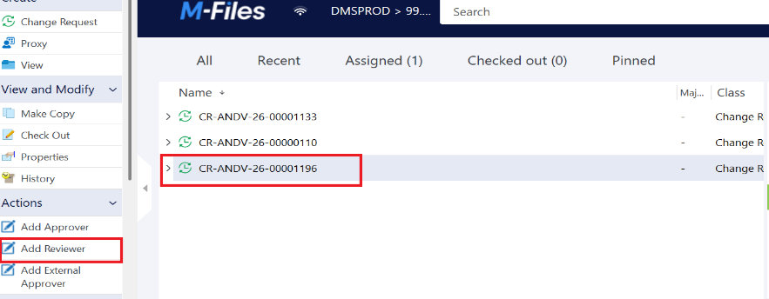

      - Add Task Assignee and Instructions and click Create
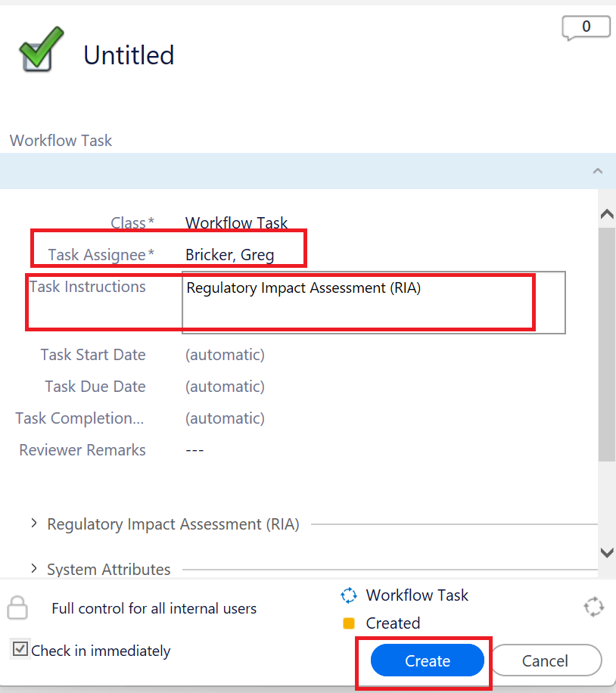
      - Highlight target CR and select Route for Review
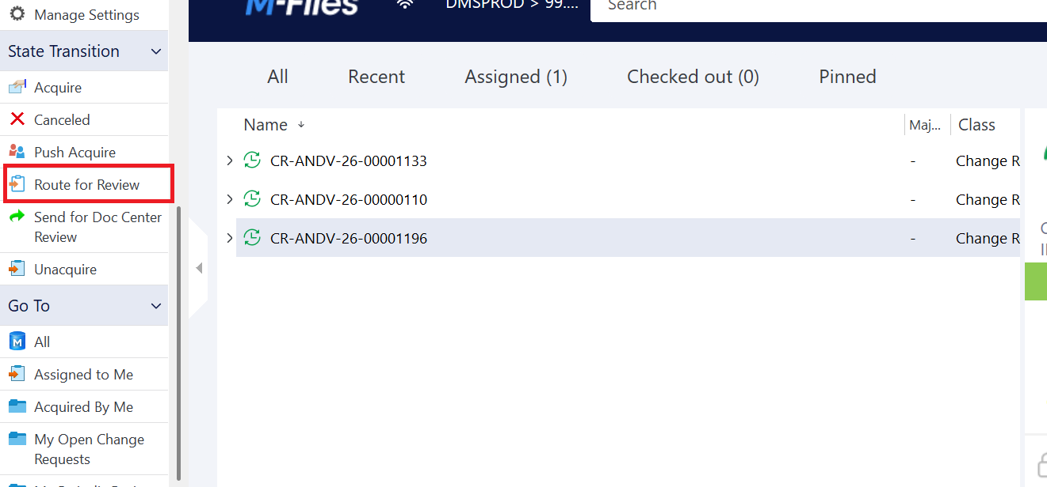
4. The CR initiator will receive email communication when the CR returns to draft status signaling the RIA is complete
Add verbiage you must Acquire

  - Submit the CR for Doc Center Review Doc Center Review
      - CR Approval Details
    - GSQA and Purchasing must not approve the CR until ALL supplier signed specifications are received and reviewed for acceptance (See CR Closure/Final Approval of ICS)
    - If a CR includes more than one GSQA approver, determine which will complete the final approval on the ISRF
    - Once all approvers EXCEPT Procurement & GSQA have approved in M-Files you may proceed to external approval
    - In situations of extreme urgency, internal and external approval may be routed in parallel, but there is risk of rework. This risk increases with length of time between supplier review and approval and complexity of specification change.

- External approval of ICS
    - Contacts
      - Unless otherwise informed by the supplier or AN Procurement, send the final draft to the supplier contacts from the external review phase

    - General Guidance
      - Prepare the ICS for external approval
      - Confirm the CR is in “Route for Approval” State and that all internal approvers, excluding GSQA and Purchasing, have approved the CR.
      - Pull the CDC (PDF) version of the ICS:
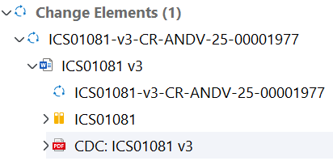
      - Save the PDF as “ICS[COMMODITY NUMBER] Final Draft”
      - Remove the final metadata pages titled “Document Properties” and “Change Request Properties” as this information is for internal reference only.
      - Add the Signature Stamp to the last page of the specification (Signature Stamp)

    - Send the Final Draft for Supplier Sign-Off
      - Use the External Approval Phase email template
      - Copy the appropriate AN Procurement (buyer) contact
      - Include a specific due date for the supplier’s response (recommendation = 1 week)
      - Email suppliers separately to maintain confidentiality

- CR Closure/Final Approval of ICS
  - General Guidance
    - Review all signed final drafts for “clean” sign-off (no redlines, comments, etc.)
    - If signed by a Broker/Distributor, confirm acceptance with AN Procurement (buyer)
    - Send all supplier signed final drafts to the Doc Center (angdinbox@abbott.com), GSQA (final approver) and Purchasing (CR approver)
      - GSQA and the Purchasing Coordinator will review the signed final drafts and approve the CR if acceptable
      - The doc center will attach the signed final drafts to the CR, complete the external approval, and close the CR
    - The ICS will now be in Approved status with a header including the Approved and Effective Date

- Final Communication

    - Contacts
      - Unless otherwise informed by the supplier or AN Procurement, send the final draft to the supplier contacts from the external approval phase
      - If the ASL lists Brokers/Distributors, consult procurement to determine if any should receive communication of the approved ICS.

    - General Guidance
      - Communication to Suppliers
      - Use the External Completion Phase email template
      - Add Outlook Read Receipt and Delivery Receipt
      - Pull the approved ICS from M-files , remove all additional pages from the PDF, and send to all suppliers including distributors/brokers as directed by Procurement
    - Communication within AN
      - Send a copy of the Read Receipt, Delivery Receipt, or email response from supplier to the Purchasing Coordinator who approved the CR
      - Note: All impacted sites are informed of the newly issued ICS via automatic M-Files communication

    - Add ICS CR Closeout date to the CR Close Out Date column of the
Incoming Acceptance Document Tracker (ICS, RMTM and CP)

